Source ID - 77554099

Source Title - Qiche Gongcheng/Automotive Engineering

Click English to browse English translation

Agreement URL - <http://www.qichegongcheng.com/>

NOTE – Chinese and English TOC should be captured.

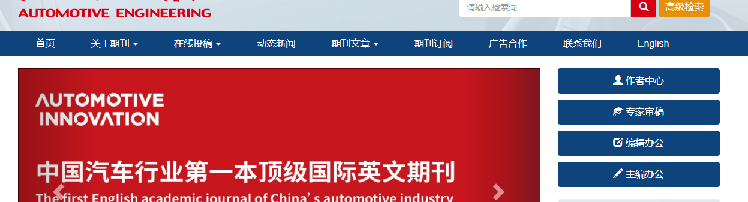

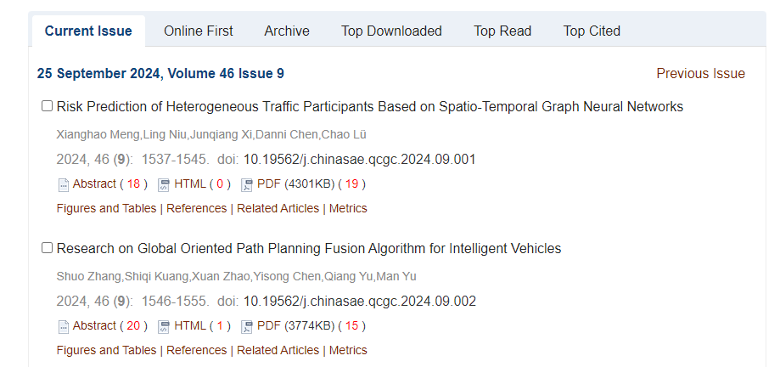

Click article title to capture meta data

Volume issue month date and year

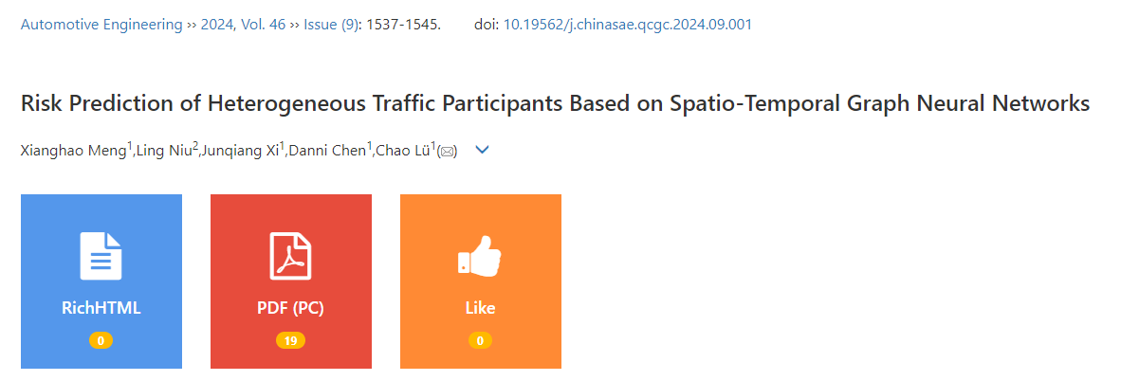

Page range

Click to download PDF

Article title

DOI number